**Tape Integration Basic Functionality**

Name (s): [Jackie.zhang@3vr.com](mailto:Jackie.zhang@3vr.com)

Date: (03/01/2016)

**Basic Functionality**

1. **Backup data files to Tape**
   * **VMS/Appliance backup data to Extended Storage Server.**
   * **Extended Storage Server is connected to Quantum Disk Cache through fiber channel and Quantum Disk Cache is a logical drive for Extended Storage Server. All the files from VMS/Appliance directly stored in Quantum Disk Cache’s “UnManaged” folder initially. Folder structure like below: Z:\UnManaged\88aea1d6-f337-4800-ada0-497a8a81200c\2016_02_20\11**

**Note:**

**1). Z: is the Quantum Disk Cache drive.**

**2). 88aea1d6-f337-4800-ada0-497a8a81200c is GUID of VMS/Appliance.**

**3). If there are lots of VMS/Appliance backup data to same Tape, there will lots of GUID folders under UnManaged folder.**

* + **Extended Storage Server will check whether should do tar by the “MaxUnmanagedDays” setting (please check UnManaged\tapestorageconfig.xml).**
  + **If there are data files older than “MaxUnmanagedDays”, Extended Storage Server will do below things:**

**1). Get current pole configuration of this VMS/Appliance from pole_configuration.xml (Note: this configuration file stored in ES, when ESS start and 23 p.m., ESS will get it from ES and store it in Temp folder of ESS.**

**2). Create a pole map file for this VMS/Appliance and store it under VMS/Appliance’s GUID folder.**

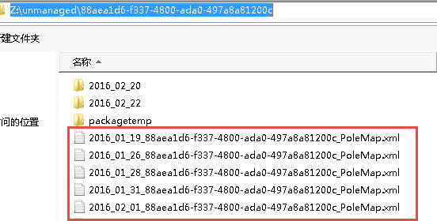

**Pole map file name pattern is: yyyy_MM_dd_GUID_PoleMap.xml**

**3). Create a “packagetemp” folder to store will packaged data. Move need package data to “packagetemp” folder and split them by pole configuration.**

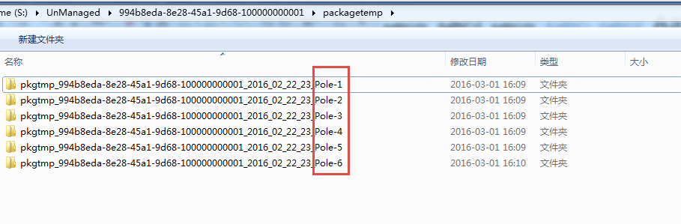

**For example:**

**Pole-1 contains channel1 to channel9, so will move channel1 to channel9’s data to pkgtmp_GUID_Date_Hour_Pole-1 folder.**

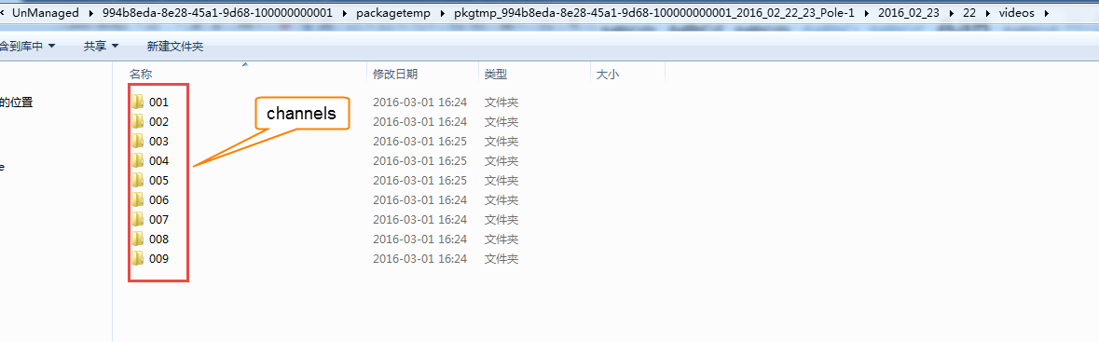

* + **Extended Storage Server start TapePackager.exe to do tar. Below is the tar command:**

TapePackager.exe tarc <Parent ESS PID> <SourceFolder> <TargetFile> <Tar_Block_Factor>

**For example:**

**TapePackager.exe tarc 24352 "Z:\UnManaged\994b8eda-8e28-45a1-9d68-100000000001\packagetemp\pkgtmp_994b8eda-8e28-45a1-9d68-100000000001_2016_02_22_23_Pole-1" "Z:\UnManaged\994b8eda-8e28-45a1-9d68-100000000001\packagetemp\packaging\pkgtmp_994b8eda-8e28-45a1-9d68-100000000001_2016_02_22_23_Pole-1.tar" 20**

* + **If set “TarProcessCount” of tapestorageconfig.xml to 2, that is means there are 2 TapePackager.exe running to do tar, and also there are two tar files in packaging folder.**

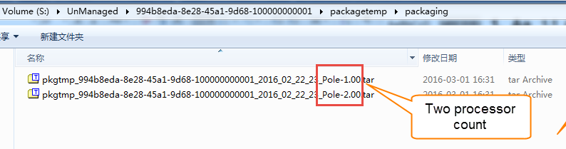

* + **After tar one package over, this TapePackager.exe will tar another pole package.**

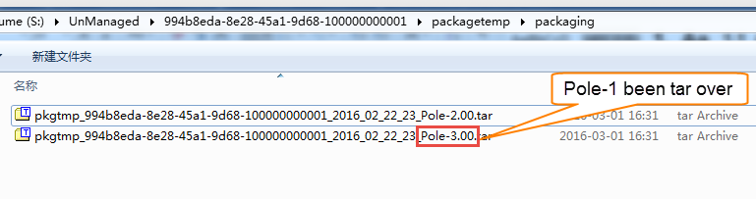

* + **After package done, Extended Storage Server will move it to “Z:\Managed” folder by data’s date**

**For example:**

**Package date is 2016_02_21, Extended Storage Server will first check whether exists “2016_02_21” folder under “Z:\Managed” folder, if not, create it. And then move package file to “Z:\Managed\2016_02_21” folder.**

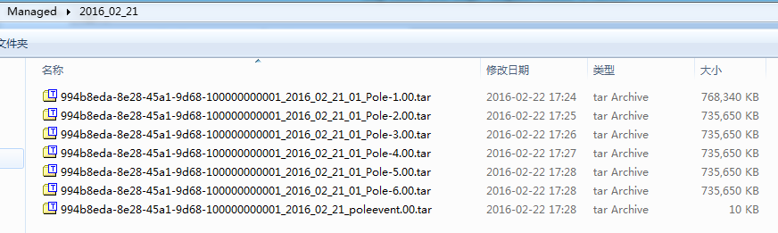

**Note:**

**Could change “TarBlockFactor” and “TarProcessCount” to change tar speed.**

**About these two settings, please check Z:\UnManaged\tapestorageconfig.xml**

* + **After move to “Managed” folder done, delete the folders and files related to tar files from “UnManaged” folder immediately.**

1. **Retrieve data files from Tape**
   * **Click “Load” or “Load All” button from OpCenter, VMS/Appliance will send “LoadFileRequest” to Extended Storage Server.**
   * **Extended Storage Server will get related package names by ApplianceGuid, Playback Date Time and Channel IDs from pole map file.**
   * **Extended Storage Server will call REST API provided by Quantum to retrieve tar files from Tape and store package file in “Z:\UnManaged\UnManaged_Cache” folder.**

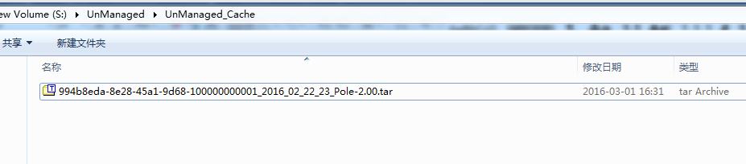

* + **After tar file retrieved from Tape, Extended Storage Server will do below things:**

1. **Create a temp folder for un-tar, temp folder name is “unpkgtmp_{ApplianceGUID}”**

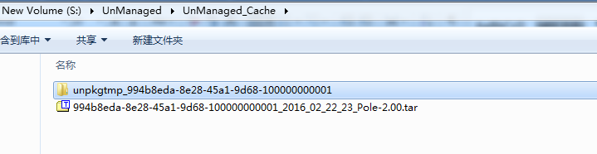

1. **Start TapePackage.exe to un-tar package file.**

**Below is the un-tar command:**

TapePackager.exe tarx <ParentPID> <SourceFile> <TargetFolder> <Tar_Block_Factor>

**For example:**

TapePackager.exe tarx 24352 "Z:\Managed\2016_02_23\994b8eda-8e28-45a1-9d68-100000000001_2016_02_23_22_Pole-2.00.tar" "Z:\UnManaged\UnManaged_Cache" 20

1. **Delete tar file after un-tar over.**
2. **Create package flag file to store package file details info. Flag file naming convention as: PackageName_PackageSize_LastAccessTime**

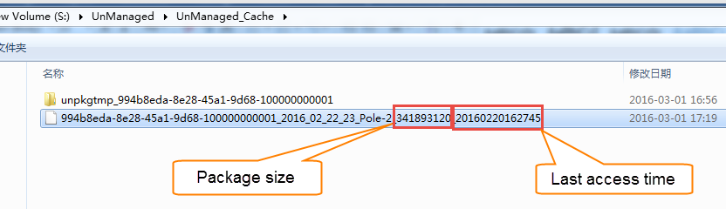

1. **Re-name unpkgtmp_994b8eda-8e28-45a1-9d68-100000000001 to package file name.**

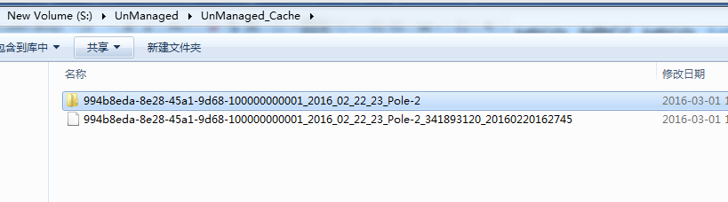

1. **Extended Storage Server send notification to VMS/Appliance, VMS/Appliance notifies to OpCenter that the request data is available to view.**

**Folder Structure**

1. **Managed**
2. **UnManaged**
3. **UnManaged_Cache**

Z:\

UnManaged

VMS GUID

Date

Hour

Channels

Video files

UnManaged_Cache

Un-tar package folder

Flag file

Managed

Date

Tar files

**Related Config Files**

1. **Pole Configuration**

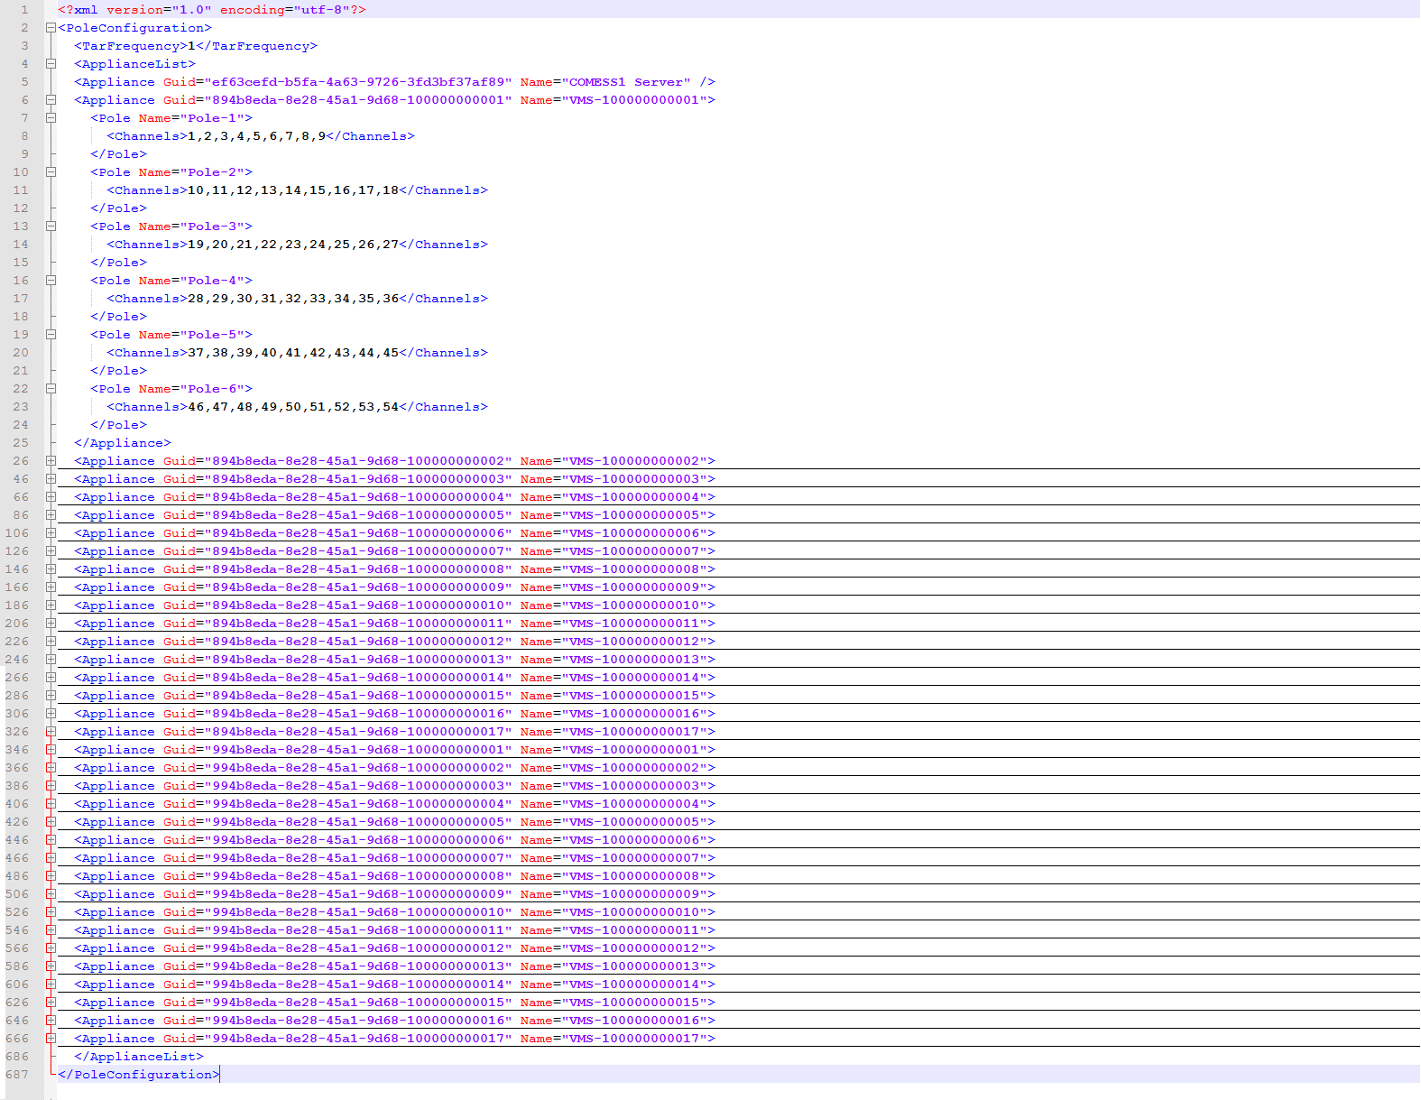

1. **PoleMap.xml**

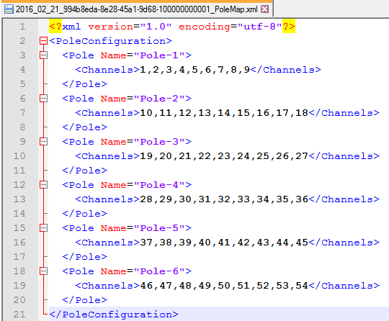

1. **Tape Storage Config**

